**Employees management System**

**To M’s Kainat Nazir Database Project Submitted By:**

**Department of computer science**

**Air University, Islamabad**

Jahnzaib Hassan – 232487

Hussnain Dogar –

232517

**1. Introduction:**

The Employee Management System (EMS) is a database project aimed at efficiently managing employee-related information within an organization. It provides a centralized platform for storing, retrieving, and managing various data related to employees, including personal details, job information, attendance records, salary details, and performance evaluations.

**2. Purpose:**

The primary purpose of the Employee Management System is to streamline the employee management process within an organization. It aims to replace manual and paper-based systems with a digital solution that offers several benefits:

• Centralized Database

• Efficient Data Management

• Automation

• Enhanced Security

• Decision Support

**3. Work and Use:**

The Employee Management System consists of several modules that cater to different aspects of employee management:

**• Employee Information Module:** This module stores and manages employee details such as name, address, contact information, employment history, and qualifications.

**• Attendance Tracking Module:** The system tracks employee attendance using various methods such as biometric scanning, RFID cards, or manual entry. It records employee attendance data, including clock-in/out times, leaves taken, and absences.

**• Payroll Processing Module:** This module calculates employee salaries based on attendance records, overtime hours, deductions, and other factors. It generates payslips and facilitates salary disbursement.

**• Performance Evaluation Module:** The system conducts periodic performance evaluations of employees based on predefined criteria and generates performance reports. It helps in identifying top performers, areas for improvement, and training needs.

**• Leave Management Module:** Employees can apply for leaves through the system, which is then routed to their supervisors for approval. The module tracks different types of leaves (e.g., annual leave, sick leave) and maintains leave balances.

**• Reporting and Analytics Module:** This module provides various reports and analytics related to employee data, such as attendance reports, salary reports, turnover rates, and employee demographics. It helps in monitoring trends and making data-driven decisions.

**4- ERD:**

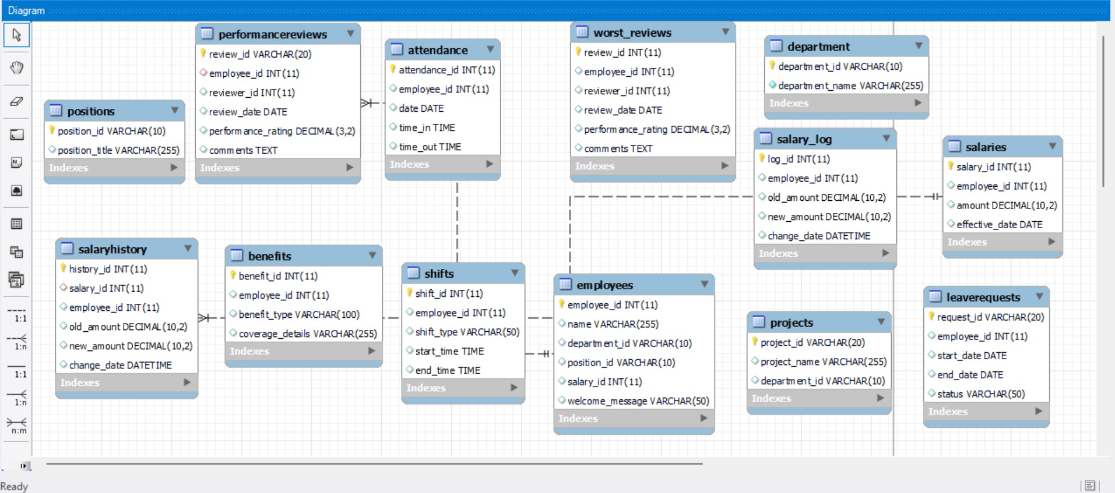

**5- Code Structure**

The implementation follows a modular approach with a clear separation of concerns. The key components are structured as follows:

1. **Stored Procedures**: Procedures are created to handle common operations like adding, updating, and removing employees, as well as other domain-specific tasks such as managing projects and leave requests.
2. **Triggers**: Triggers are set to automatically handle specific events like inserts or updates in the database, ensuring data integrity and automated logging.
3. **Functions**: Functions are defined to encapsulate reusable logic, such as calculating an employee's salary.

**6- Modules and Functions**

**6.1. Stored Procedures**

* AddEmployee Procedure.
* UpdateEmployeeDepartment Procedure
* RemoveEmployee Procedure
* AddProject Procedure
* GetEmployeeLeaveRequests Procedure
* GetEmployeesBySalary Procedure
* GetEmployeesByBenefit Procedure

**6.2. Functions**

* GetEmployeeSalary Function

**6.3. Triggers**

* Before Insert Employee Trigger
* After Salary Update Trigger
* Before Leave Request Insert Trigger
* Before Salary Insert Trigger
* Check Performance Rating Trigger
* Move to Worst Review Trigger

**7- Sample Usage and Testing**

* **Adding an Employee**

CALL AddEmployee(42, 'JAHANZAIB HASSAN', 'D142', 'PS1042', '42');

* **Updating Employee Department**

CALL UpdateEmployeeDepartment(1, 101);

* **Removing an Employee**

CALL RemoveEmployee(1);

* **Getting Employee Salary**

SELECT GetEmployeeSalary(10);

* **Adding a Project**

CALL AddProject('PROJ001', 'New Project', 101);

* **Querying Data**

SELECT * FROM Projects; SELECT * FROM Employees; SELECT * FROM Department;

* **Testing Triggers**

UPDATE Salaries SET amount = 75000.00 WHERE salary_id = 1; SELECT * FROM SalaryHistory; INSERT INTO LeaveRequests (request_id, employee_id, start_date, end_date, status) VALUES ('LR123', 1001, '2023-01-01', '2023-01-10', 'Pending'); -- Should fail due to trigger INSERT INTO LeaveRequests (request_id, employee_id, start_date, end_date, status) VALUES ('LR124', 1002, '2024-06-01', '2024-05-31', 'Pending'); -- Should fail due to trigger

**8- Interface Images:**

